Assignment No. 1

Process Model Selection
University Timetable Optimization and Management System
──────────────────────────────────────────────────────────────
Course | Software Engineering
Document Type | Formal assignment
Project | University Timetable Optimization and Management System
Purpose | Process modelling / software analysis

Prepared for academic submission. The content is project-specific and framed for a university timetable optimization website.

1. Introduction
The proposed project is a web-based University Timetable Optimization and Management System. Its purpose is to generate, review, repair, and publish weekly schedules for courses, teachers, rooms, and student groups under both mandatory restrictions and configurable institutional goals.
The project is not a simple data-entry application. It combines master-data management, rule configuration, schedule generation, conflict analysis, manual override handling, and controlled re-optimization after changes. Because the system is both policy-driven and highly visual, the process model must support staged learning, frequent validation, and disciplined documentation.

2. Project Characteristics That Influence Process Selection
- Rules are partly known at the start, but some constraints become visible only after draft timetables are viewed.
- Stakeholders need visual feedback through forms, timetable grids, conflict summaries, and policy-setting screens.
- The project contains technical uncertainty in constraint handling, timetable repair, and minimal-disruption updates.
- The project is modular enough to be delivered in stages: data setup, rules, generation, review, repair, and publication.
- The assignment context still expects formal documentation, not only code iterations.

3. Selection Criteria
The following criteria were used to evaluate candidate process models. They were selected because they are directly relevant to a timetable system rather than being generic project-management checkpoints.
Criterion | Why it matters in this project
Requirement volatility | New constraints and policy weights may appear after early timetable drafts are reviewed.
Need for visual validation | Users must see prototypes of timetable screens and generated schedules before requirements feel complete.
Technical uncertainty | Constraint handling, repair, and re-optimization are not trivial and should be isolated early.
Phased delivery | The system naturally decomposes into increments with meaningful intermediate outputs.
Documentation needs | The subject requires structured justification, diagrams, and traceable reasoning.
Testing strategy | Each module should be testable before later modules depend on it.
Semester scope | The process must suit a controlled academic timeline and avoid heavy management overhead.

4. Candidate Models Considered
Four conventional approaches were considered. The goal was not merely to list textbook definitions, but to judge which model best fits a small but conceptually rich scheduling system.
Model | Main strength | Main limitation for this project | Fit
Waterfall | Strong documentation; clear sequential control | Weak fit for hidden timetable exceptions and late policy changes | Low
Incremental | Builds the system in manageable releases with review after each stage | Needs good decomposition and discipline across increments | High
Spiral | Very strong on risk control and repeated evaluation | Too heavy for a semester project of this scale | Medium
Agile / XP practices | Useful for feedback and frequent adjustment | Can become under-documented if used without formal controls | Medium

5. Criteria-to-Model Evaluation Matrix
To make the choice more disciplined, the candidate models were compared against the selection criteria below. Scores range from 1 (weak fit) to 5 (strong fit). The totals are not meant to be mathematically absolute; they simply make the reasoning explicit and defensible.
Criterion | Wt. | Waterfall | Incremental | Spiral | Agile/XP
Requirement volatility | 5 | 2 | 5 | 4 | 4
Visual validation need | 4 | 2 | 5 | 4 | 4
Technical uncertainty | 4 | 2 | 4 | 5 | 4
Phased delivery | 4 | 3 | 5 | 4 | 4
Documentation needs | 4 | 5 | 4 | 4 | 2
Testing practicality | 3 | 3 | 5 | 4 | 4
Semester-scale manageability | 4 | 3 | 5 | 2 | 3
Weighted total |  | 71 | 125 | 106 | 96

6. Selected Process Model
The selected process model is the Incremental Process Model. Prototyping is not treated as a separate primary model; rather, it is used as a supporting technique inside the early increments to validate the user interface, data-entry workflow, and rule-configuration screens.
This wording is academically more precise because the core lifecycle remains incremental, while prototyping serves as an early validation method.
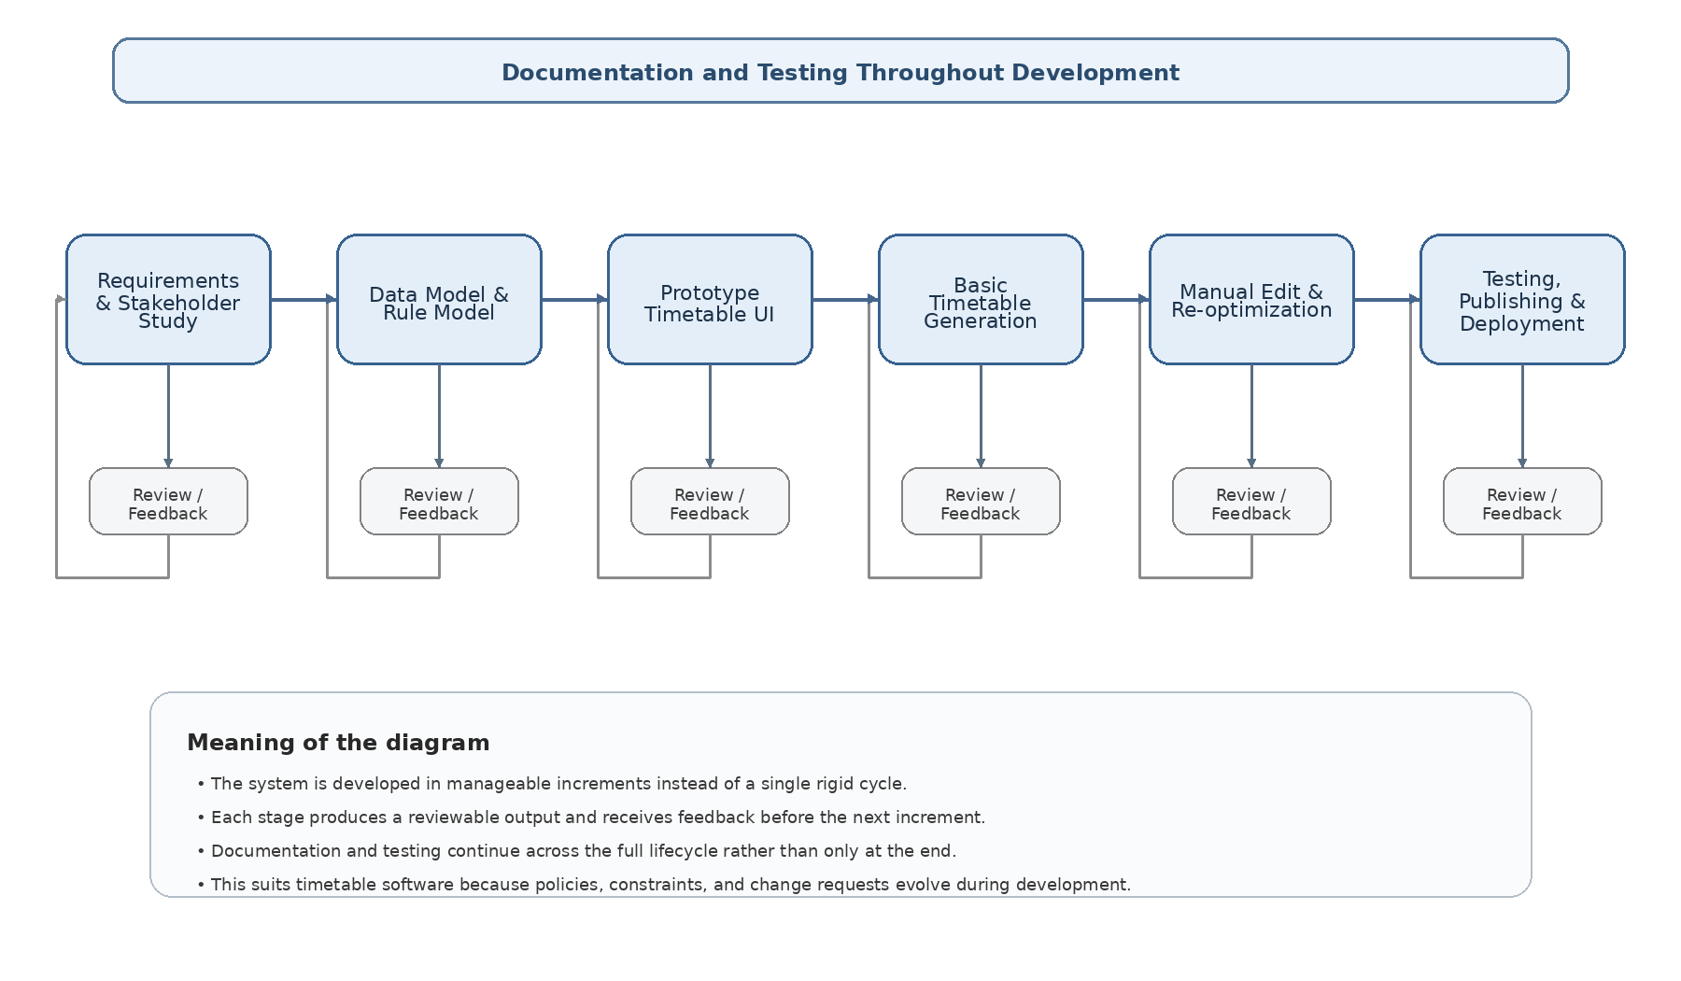
Figure 1. Incremental Process Model with embedded review and feedback loops.

6.1 Diagram Description
The figure shows that development begins with requirements and stakeholder study, moves through data and rule modelling, then produces an early prototype before timetable generation is attempted. Each major stage has a review/feedback path. This is important because timetable rules are often discovered or refined after users see sample schedules. The diagram also emphasizes that documentation and testing continue throughout the lifecycle rather than appearing only at the end.
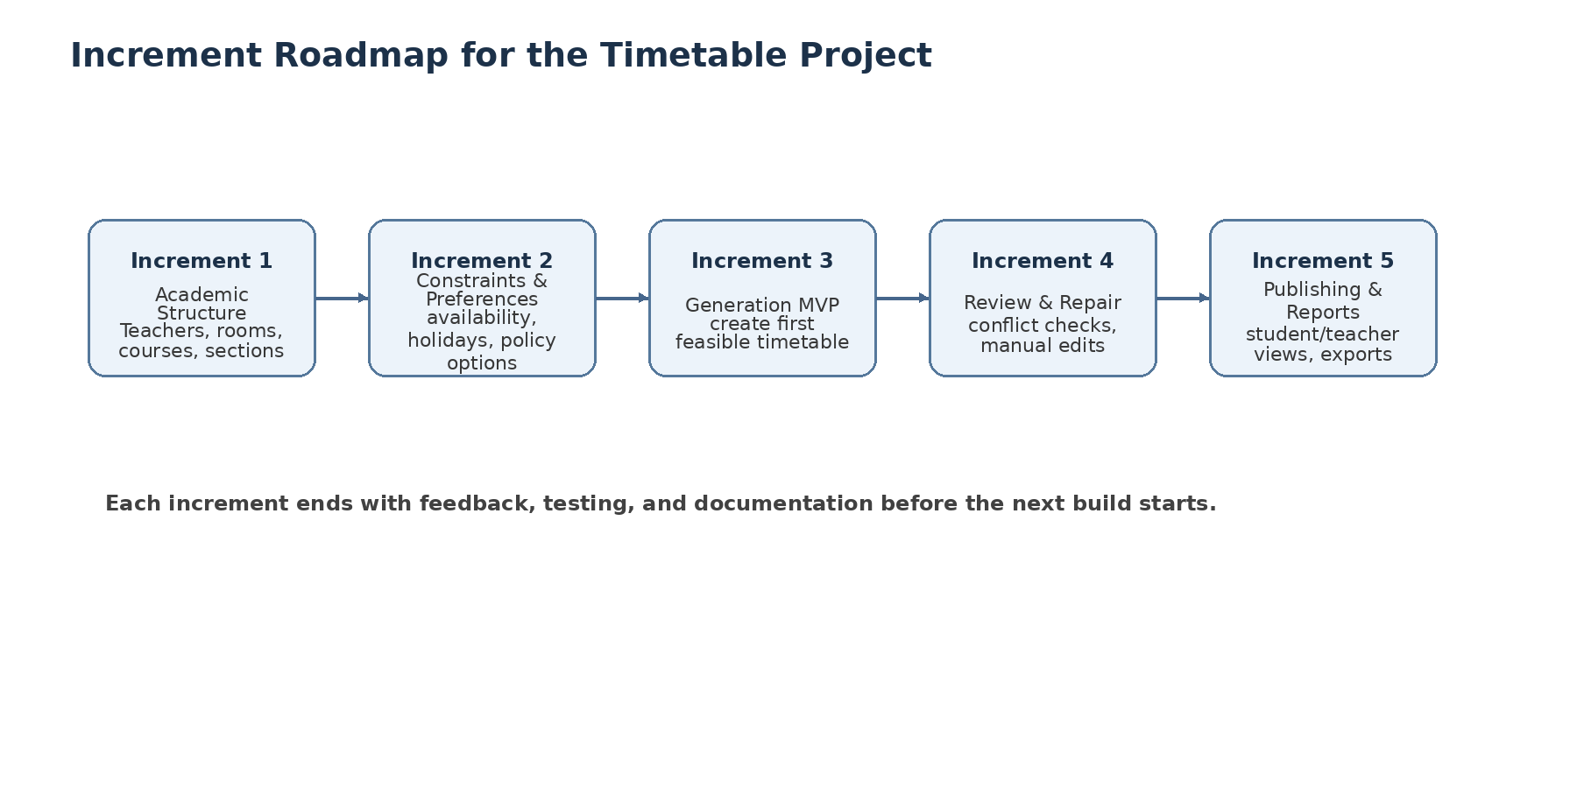
Figure 2. Proposed increment roadmap for semester-scale delivery.

6.2 Diagram Description
The roadmap turns the lifecycle into concrete delivery stages. Increment 1 establishes academic structure and resources; Increment 2 captures constraints and preferences; Increment 3 delivers a first feasible generation capability; Increment 4 focuses on review, validation, and repair; and Increment 5 completes publication and reporting. This staged structure fits the project because later capabilities depend on earlier ones, yet each increment remains independently reviewable.

7. Why Incremental Fits This Project Better Than the Alternatives

7.1 It matches the way timetable requirements emerge
A university may think its rules are already known, but hidden constraints often appear only after a draft timetable is seen. Examples include room proximity between consecutive classes, a teacher's need for a specific day pattern, or a request for minimal disturbance after a late change. Incremental delivery allows such discoveries to refine later builds without forcing a full restart.

7.2 It supports staged learning without overengineering
This project is too uncertain for Waterfall, but not large enough to justify the management weight of Spiral. Incremental development therefore occupies the practical middle ground: it tolerates learning and revision while remaining manageable for academic delivery.

7.3 It aligns with the modular architecture of the system
The software can be partitioned naturally into academic data, rule configuration, timetable generation, timetable review, repair, and publication. Because each module has a clear output, incremental development is not an artificial choice; it matches the architecture of the system itself.

7.4 It handles late changes more gracefully than Waterfall
The timetable is not finished once a first schedule is produced. Teachers may request exceptions, rooms may become unavailable, and holidays or blocked periods may need to be inserted. A strict linear model performs poorly when such changes appear after design and implementation have already advanced.

7.5 It keeps testing and documentation under control
Each increment can be validated with focused tests: data validation tests, conflict-detection tests, timetable-quality checks, repair/regeneration tests, and publishing checks. At the same time, the team can keep documents up to date after each increment rather than attempting a large final write-up.

8. Why Waterfall and Spiral Were Not Selected
Waterfall was not selected because it assumes that most important requirements can be fixed early and then implemented with limited backtracking. That assumption is weak here. Timetable systems frequently reveal missing constraints only after prototype screens or generated schedules are reviewed. If Waterfall were used, changes to policy weights, room priorities, or repair behavior would arrive late and become expensive to incorporate.
Spiral was also not selected as the main lifecycle. It does handle risk well, but it introduces more planning overhead than is justified for a semester-sized project. The scheduling logic is uncertain enough to require staged learning, but the overall system is still small enough that a lighter incremental lifecycle is more appropriate.

9. Proposed Increment Plan
Increment | Focus | Main deliverables
Increment 1 | Academic structure and resource setup | Departments, semesters, sections, teachers, rooms, buildings, time slots
Increment 2 | Constraint and preference capture | Availability, holidays, blocked periods, policy toggles, rule weights
Increment 3 | Timetable generation MVP | First feasible timetable with clash checking and basic score output
Increment 4 | Review and repair | Conflict reports, manual adjustments, change requests, controlled re-optimization
Increment 5 | Publication and access | Teacher/student views, exports, publication workflow, resource reports

10. Conclusion
The strongest argument for the selected lifecycle is this: the project contains enough uncertainty in rules, repair behavior, and stakeholder preferences to make a one-pass model risky, but it remains small and modular enough that Spiral would be unnecessarily heavy. Therefore, the Incremental Process Model is the best primary choice, with prototyping used as an early validation technique inside the first increments. This combination gives the project analytical clarity, practical flexibility, and a delivery style suitable for software engineering coursework.

Selected References
- Ian Sommerville, Software Engineering.
- Roger S. Pressman and Bruce R. Maxim, Software Engineering: A Practitioner's Approach.
- Craig Larman, Applying UML and Patterns.

